Appendix

Appendix 1: Overview of the 40 tested SSR markers
Primer name | BATG -v.05 contig number_ basepair coordinates (Sollars et al. 2017) | Repeat motif | Motif size | Forward primer sequence 5’-3’ | Reverse primer sequence 5’-3’ | Ampli-fication status | Note
FREX01§ | Contig1454_57323_57541 | (CT)8 | 2 | CCTACACAACCAATCTTTCGG | CTCGTGTTTCCTTATTTCTCCG | -
FREX02§ | Contig1795_237744_237898 | (GA)10 | 2 | TTCCTTTAACACCATCCAGC | TGGGTGGTATCGTAGAATGG | +
FREX03 | Contig26633_2328_2538 | (GGT)7 | 3 | GCCTCAACTATGTTACCGGG | CACCTGCTAATCGGTGGAGT | - | many small peaks
FREX04§ | Contig2870_107932_108200 | (TA)12 | 3 | AAACAGACCAATAATAAAGGACCA | TTACGAGGCATTGACGTGTG | -
FREX05 | Contig3086_43836_44047 | (ATA)8 | 3 | CAGTTGTTTGTTGCCGATGT | TGATATTTAAGGGAGCACACCA | -
FREX06§ | Contig3809_118941_119122 | (CT)7 | 2 | CTCAGCAATGAGAAGACCGA | TCTGGAGTAACTGGATCACCAA | +
FREX07§ | Contig3945_32119_32309 | (TG)8 | 2 | GAATCCACTTGGAAATGTACTGG | CCCAAACATGCTCTAGCCTC | +*
FREX08§ | Contig558_117347_117093 | (GGT)7 | 3 | AGAGGGCACAGGTTCTCAAG | GGACAACAAGCATGACAGGA | +*
FREX09§ | Contig754_78519_78709 | (AT)9 | 2 | TTCTACCCTTTGCTTTGCGT | AACACATCAAGATAGACCCAGAA | - | many small peaks
FREX10§ | Contig87_333704_333466 | (AG)13 | 2 | GTAGAGACGAATCGATGCCA | GGAGGTTCTCAGATGTTTGGA | +
FREX11 | Contig2215_27085_26967 | (AC)11 | 2 | GAGCACACTTGTGCATGGAG | GGTCATTCTGCAAGCAATTT | +
FREX12 | Contig2679_141554_141833 | (AG)11 | 2 | AAACCTTGTATGTGGTCGTCG | TTTGAGGAGAAATCGGAAGAT | -
FREX13 | Contig6775_4915_5104 | (AG)12 | 2 | AAGTGCACCAGAAGATCTTACCA | CAGCAATTCATTTAAGCTTTAGCTCC | -
FREX14 | Contig8902_137544_137396 | (CT)12 | 2 | ATCCTTCGCGTAATTGGAAA | ACGTCGACAGTCAGAAGCCT | +
FREX15 | Contig3861_40909_40630 | (GA)12 | 2 | TGTGATTTGGAGTTTGGCTG | GTCGGACAGGCAAATCTTGT | - | many samples dropped out
FREX16 | Contig235_122828_122527 | (GA)13 | 2 | GCTAGAAACTGTGAACATAACAGACT | CTCAATCATGGGCTAAATCAG | +
FREX17 | Contig1450_10220_10379 | (GA)8 | 2 | AGAGCTTCGTTCGTGAGAGG | TAACCCAAATCTCAGCCGTC | +
FREX18 | Contig3101_30079_29789 | (GT)13 | 2 | TTCAATCATGCATAGCAGCC | ATGTGCACCAAATGTGGTCTT | +
FREX19 | Contig584_60987_60841 | (GT)13 | 2 | CCTTCTTCATGGCATTTGCT | GATCGAGCTCATCGTCCTTC | - | one pattern showed four peaks
FREX20 | Contig355_106154_105963 | (TA)13 | 2 | CAAGTAACACGGTAAAGTTGATGA | CCATACCTTCATATAGAAGACGACA | -
FREX21 | Contig352_277551_277870 | (TC)13 | 2 | TGGGCCGTAAATTTGAGAAG | CCATAATCGTGATCAAACGG | - | many samples dropped out
FREX22 | Contig62_26633_26333 | (TG)12 | 2 | CAGTTGAAATGCAGCCATTG | ACACCACCCTACTGGTCAGC | +
FREX23 | Contig4527_31021_30779 | (TG)13 | 2 | CATCTCACTGCCACAGCACT | TGATACACGGAGAAGAAGTGAA | +
FREX24 | Contig13_160964_160820 | (AC)8 | 2 | TCAGTTCCTTCAAGTTTCGGA | TTCATAGTATAGATGCTTGATAGGTCC | 0
FREX25 | Contig84_196846_196652 | (TC)12 | 2 | CACTTCCTTCATCCGTTCGT | TGACTTCTTGTCAAGCCGGT | +
FREX26 | Contig1022_142474_142191 | (GAG)10 | 3 | TCGTTGAAATCACCCTACATATC | TTCCGGTATTTGAACATTTGA | +
FREX27 | Contig2516_59232_59464 | (TGG)7 | 3 | GGGTTGATCACCATGCACTT | GGCTTTCCTATGAACTTTCGG | - | many samples dropped out
FREX28 | Contig2564_131282_130980 | (TGG)8 | 3 | GCGACGGCATTTCTTATGTT | ATTTGGATGATCAGGATCGC | +
FREX29 | Contig258_148090_148230 | (GAA)8 | 3 | AAACCACAAACAGAACCGCT | CCACGCCTCATCATTCACTA | -
FREX30 | Contig3375_82131_82433 | (TAA)10 | 3 | CAGCCCATGGTTTCAACTACT | GTTTATGCTCTAGCAAGAAACTTGT | -
FREX31 | Contig3574_24363_24552 | (TTA)10 | 3 | GCCTCAGGAAACTAACACTACTCA | TGCCTTCTCCTCCATACGAT | +
FREX32 | Contig42_138327_138185 | (TTC)8 | 3 | TGAACTCCAGTGCTGTTGCT | CAAACTGAGACATACAGCTCAACA | -
FREX33 | Contig4369_30507_30647 | (TGG)8 | 3 | TTGTCTTTGTTCTGTGTCGAAT | CCATCACACGTTCACAGCTT | +
FREX34 | Contig4493_30641_30357 | (GGT)10 | 3 | TCACTTTAGCATCGCAACACA | TACCACCAAGGAACTGGAGG | -
FREX35 | Contig461_54895_55170 | (ATT)10 | 3 | GGTAGTGGCGGATTACTTCAA | TGGCCTGAGGATGTGGATA | +
FREX36 | Contig507_25678_25535 | (AAC)7 | 3 | GCTAATAAAGCAGATCCCTTGC | ACGAAGATGGCAATATAAGGATG | +
FREX37 | Contig5194_81952_82170 | (TTA)9 | 3 | ACAAGGAGATCAATGGCTGC | AAATTTGGGTGGCAACATAG | 0
FREX38 | Contig5324_54899_55109 | (AAG)7 | 3 | TTGATCCCACAACTCACAGG | TTCAATGGCTCAGTCTGTGG | -
FREX39 | Contig5412_164597_164354 | (ATT)7 | 3 | AAATACAAGCCACGTTCTTTCTC | TTCTAGGCCTGTCCTCAGGT | -
FREX40 | Contig5984_30262_30463 | (CCT)10 | 3 | CAATCTTGGACTACTCTTGGGTG | GGAAGAAGCAGTGCCAGAAA | +
+ clear allele patterns recognisable, 0 probably monomorphic, - unspecific amplification
* In contrast to the test run, in the scoring of the alleles from the amplification of all samples, these two markers could not be genotyped unambiguously and therefore were not included in the further analyses.
§ Markers located in the neighbourhood (same contig and maximum distance of 65,000 bases) of candidate genes that have been linked to ash dieback resistance by Stocks et al. (2019).
Appendix 2: Multiplexes combining PCR products with a HEX label (green) and PCR products with FAM label (blue) each of two or three microsatellite markers, for determination of the fragment lengths in a genetic analyser. Markers in one row assigned to the same label (FAM or HEX) were combined during PCR, while all markers written in one row (e.g. Multiplex 1) were run jointly on the ABI 3130 xl Genetic Analyzer.
Multiplex | M13 6-FAM (blue) | Mixing ratio | M13 HEX (green) | Dilution
Multiplex 1 | FREX22 | 1:100 | FREX06, FREX10 | 1:100
Multiplex 2 | FREX07, FEX35, FREX36 | 1:60 | FREX14, FREX16 | 1:30
Multiplex 3 | FREX28, FREX40 | 1:80 | FREX26, FREX31 | 1:40
Multiplex 4 | FREX17, FREX23 | 1:80 | FREX18, FREX25 | 1:52
Multiplex 5 | FREX02 | 1:20 | FREX11 | 1:20
Multiplex 6 | FREX08 | 1:200 | FEX33 | 1:200

Appendix 3: Genetic characterisation of the 18 successfully amplified polymorphic microsatellite markers in the two F. excelsior populations BSA and E with 16 examined individuals per population.
Locus | BSA (n = 16) |  |  |  |  |  |  |  |  |  |  |  | E (n = 16)
 | N | N_{a} | N_{e} | N_{PA} | A  (k=24) | H_{o} | H_{e} | F_{IS} (p) |  | N | N_{a} | N_{e} |  | N_{PA} | A  (k=24) | H_{o} | H_{e} | F_{IS} (p) |  | F_{ST} (p)
FREX02 | 16 | 7 | 2.21 | 2 | 6.32 | 0.44 | 0.55 | 0.23 (0.092) |  | 16 | 8 | 2.39 |  | 3 | 6.89 | 0.56 | 0.58 | 0.07 (0.597) |  | -0.021 (0.887)
FREX06 | 16 | 5 | 2.47 | 3 | 4.88 | 0.69 | 0.60 | -0.12 (0.451) |  | 16 | 4 | 1.48 |  | 2 | 3.50 | 0.38 | 0.32 | -0.13 (0.558) |  | 0.045 (0.056)
FREX10 | 16 | 13 | 7.53 | 5 | 11.31 | 0.88 | 0.87 | 0.02 (0.737) |  | 16 | 15 | 11.13 |  | 7 | 13.2 | 0.88 | 0.91 | 0.07 (0.322) |  | 0.008 (0.252)
FREX11 | 16 | 10 | 4.61 | 2 | 9.01 | 0.50 | 0.78 | 0.39 (0.001) |  | 16 | 10 | 8.39 |  | 2 | 9.56 | 0.69 | 0.88 | 0.25 (0.013) |  | 0.026 (0.118)
FREX14 | 16 | 10 | 7.31 | 3 | 9.13 | 0.81 | 0.86 | 0.09 (0.328) |  | 16 | 8 | 6.17 |  | 1 | 7.63 | 0.75 | 0.84 | 0.14 (0.209) |  | -0.013 (0.751)
FREX16 | 16 | 5 | 1.99 | 1 | 4.68 | 0.44 | 0.50 | 0.15 (0.378) |  | 16 | 7 | 3.32 |  | 3 | 6.61 | 0.56 | 0.70 | 0.23 (0.087) |  | 0.008 (0.285)
FREX17 | 16 | 5 | 1.85 | 0 | 4.64 | 0.50 | 0.46 | -0.06 (0.789) |  | 16 | 8 | 3.82 |  | 3 | 7.14 | 0.69 | 0.74 | 0.10 (0.414) |  | 0.051 (0.048)
FREX18 | 16 | 7 | 4.74 | 0 | 6.44 | 0.94 | 0.79 | -0.16 (0.195) |  | 16 | 10 | 6.74 |  | 3 | 9.11 | 0.81 | 0.85 | 0.08 (0.421) |  | -0.015 (0.841)
FREX22 | 16 | 4 | 1.39 | 1 | 3.64 | 0.25 | 0.28 | 0.14 (0.378) |  | 16 | 5 | 2.61 |  | 2 | 4.73 | 0.75 | 0.62 | -0.18 (0.238) |  | 0.088 (0.019)
FREX23 | 16 | 8 | 5.33 | 1 | 7.43 | 0.69 | 0.81 | 0.19 (0.108) |  | 16 | 8 | 5.39 |  | 1 | 7.24 | 0.50 | 0.81 | 0.41 (0.001) |  | -0.028 (0.930)
FREX25 | 16 | 11 | 5.89 | 0 | 9.43 | 0.88 | 0.83 | -0.02 (0.885) |  | 16 | 15 | 8.26 |  | 4 | 12.61 | 0.88 | 0.88 | 0.04 (0.618) |  | -0.003 (0.549)
FREX26 | 12 | 4 | 2.97 | 2 | 4.00 | 0.08 | 0.66 | 0.88 (0.000) |  | 13 | 6 | 3.13 |  | 4 | 5.84 | 0.15 | 0.68 | 0.79 (0.000) |  | 0.067 (0.092)
FREX28 | 16 | 5 | 4.41 | 1 | 4.99 | 0.94 | 0.77 | -0.18 (0.170) |  | 16 | 6 | 2.19 |  | 2 | 5.61 | 0.63 | 0.54 | -0.12 (0.416) |  | 0.124 (0.000)
FREX31 | 16 | 8 | 4.00 | 3 | 7.37 | 0.88 | 0.75 | -0.14 (0.250) |  | 16 | 6 | 3.01 |  | 1 | 5.43 | 0.69 | 0.67 | 0.00 (0.977) |  | 0.073 (0.010)
FREX33 | 16 | 4 | 2.68 | 0 | 3.93 | 0.81 | 0.63 | -0.27 (0.140) |  | 16 | 6 | 3.10 |  | 2 | 5.64 | 0.69 | 0.68 | 0.02 (0.861) |  | 0.034 (0.098)
FREX35 | 16 | 8 | 3.68 | 3 | 7.22 | 0.81 | 0.73 | -0.08 (0.511) |  | 15 | 7 | 4.89 |  | 2 | 6.92 | 0.93 | 0.80 | -0.14 (0.241) |  | 0.016 (0.157)
FREX36 | 16 | 5 | 3.82 | 1 | 4.75 | 0.81 | 0.74 | -0.07 (0.667) |  | 16 | 6 | 3.76 |  | 2 | 5.68 | 0.81 | 0.73 | -0.07 (0.605) |  | 0.013 (0.213)
FREX40 | 16 | 6 | 2.69 | 1 | 5.39 | 0.75 | 0.63 | -0.16 (0.341) |  | 16 | 6 | 2.14 |  | 1 | 5.24 | 0.56 | 0.53 | -0.02 (0.934) |  | 0.001 (0.369)
Mean | 15.8 | 6.9 | 3.86 | 1.61 | 6.36 | 0.67 | 0.68 | 0.05 |  | 15.8 | 7.8 | 4.55 |  | 2.5 | 7.14 | 0.66 | 0.71 | 0.09 |  | 0.026
SD | 0.22 | 2.59 | 0.43 | 1.34 | 2.16 | 0.06 | 0.04 | 0.26 |  | 0.17 | 2.95 | 0.62 |  | 1.42 | 2.48 | 0.05 | 0.04 | 0.23 |  | 0,04
N = sample size, N_{a} = number of alleles, N_{e} = effective number of alleles, N_{PA} = number of private alleles when comparing BSA and E, A (k=24) = Allelic richness (expected number of alleles among 24 gene copies after rarefaction), H_{o} = observed heterozygosity, H_{e} = expected heterozygosity, F_{IS} = individual inbreeding coefficient, p = Pval(Fi<>0) after 10,000 randomisation of gene copies among individuals, F_{ST} = fixation index, SD = standard deviation.
BSA = a F. excelsior population in Bad Sooden-Allendorf (51°15'11.7 "N 10°01'45.1 "E), E = a F. excelsior population north of Scheden in the district of Göttingen (51°27'57.5 N, 009°45'56.6 E).

Appendix 4: Typical amplification patterns of the markers
Marker | Typical pattern | Note
FREX02 | 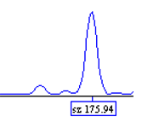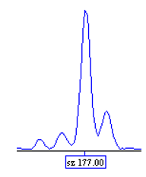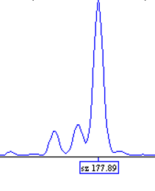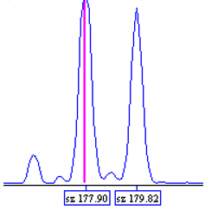 | Alleles with only one bp distance occur: 176/177/178, E8 has allele at 183 bp, which does not appear elsewhere
FREX06 | 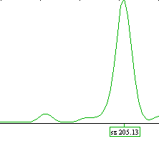
FREX10 | 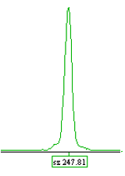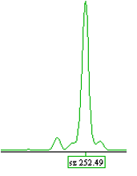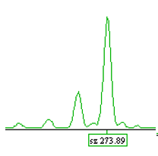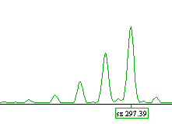
FREX11 | 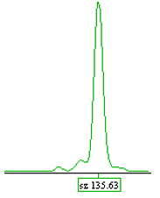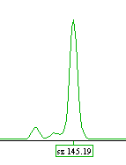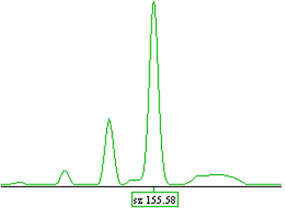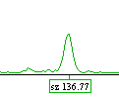 | Often small peaks in different places
FREX14 | 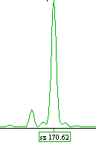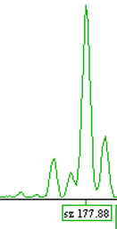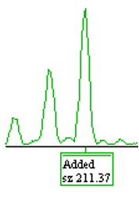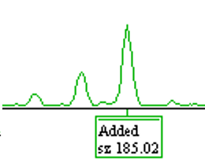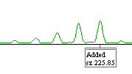 | Peak at 164 bp
FREX16 | 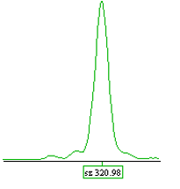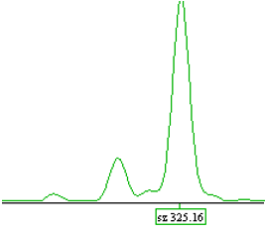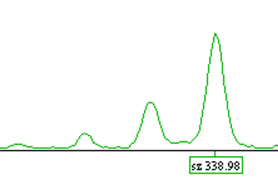
FREX17 | 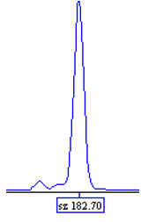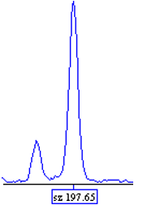
FREX18 | 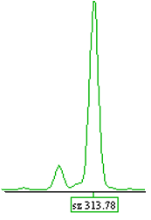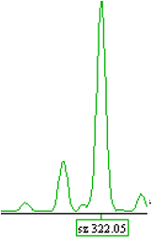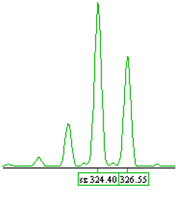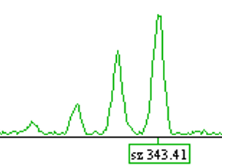
FREX22 | 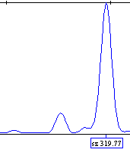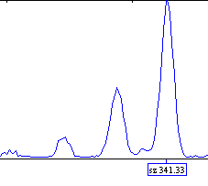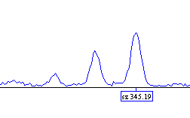
FREX23 | 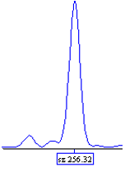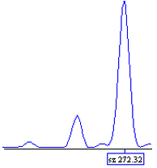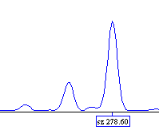
FREX25 | 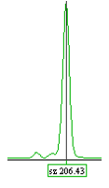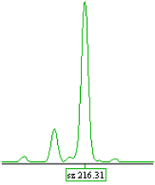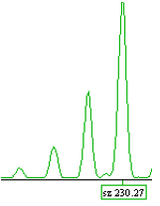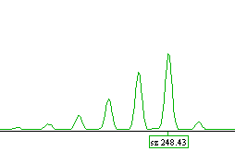
FREX26 | 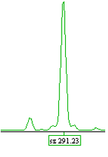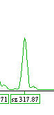
FREX28 | 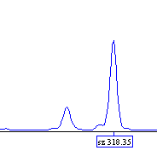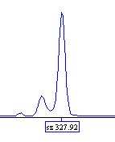 | Often small peak at 326 bp
FREX31 | 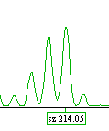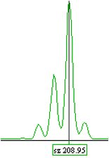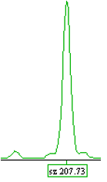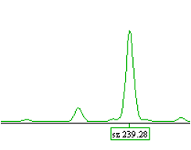
FREX33 | 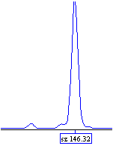 | False (additional) peak everywhere in different places
FREX35 | 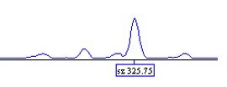  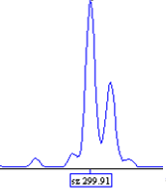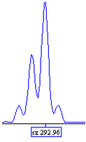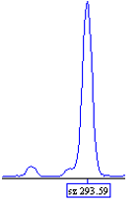
FREX36 | 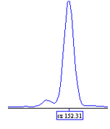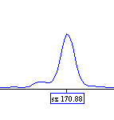
FREX40 | 